A Report on VLE for Open University

Introduction:
Distance learning is one of the natures of the university, and the Open University (OU) is a pioneer in the field – offering accessible and flexible studying to the students from all over the world. However, I’m a nerd, and I get to leverage data to tell the OU how their VLE affect student outcomes.
This report addresses two main questions:
- Is the VLE improving students' grades?
- Can we predict students' grades?
In order to answer these questions, we will analyze the Open University Learning Analytics Dataset (OULAD). The rich data in this dataset includes student demographic information, VLE interactions, module assessments and academic performance. The analysis will include statistical modeling, exploratory data analysis, and hypothesis testing to draw evidence-based conclusions.
Explore the dataset to understand student engagement patterns, assessment outcomes, and demographic trends.
- Develop predictive models to identify the factors influencing academic performance.
- Evaluate the effectiveness of the VLE by examining its correlation with student grades.
The hypotheses guiding this analysis are:
- H1: It is found that more interaction with the VLE enhances student grades.
- H2: A combination of demographic data, interaction metrics in the VLE and assessment scores accurately predicts student grades.
How the Open University Sets Up Its Modules and Assessments
- Modules and Course Structure:
- The Open University (OU) uses modular system.
- Modules are typically in 8 to 9 Months and include structured learning materials, assignments, and assessments.
- Each module is identified by a unique code and is designed to cater to diverse student demographics, emphasizing accessibility and flexibility.
- Assessments:
  - OU assessments are varied to suit different learning objectives and include Tutor Marked Assessment (TMA), Computer Marked Assessment (CMA), or Final Exam.
Web based platform in which online education is imparted to the learners by means of tools and resources for learning and interaction is known as Virtual Learning Environment (VLE).
As part of its distance learning model, the OU’s VLE sits at the center of students’ engagement with their studies despite diverse physical locations.
The dataset you're analyzing (OULAD) contains multiple interconnected tables that provide a rich source of data about students, modules, assessments, and VLE interactions.
- courses.csv: Contains information about each course and its associated modules (e.g., course code, module presentation).
- Example: A module might be “AAA_2021J” (Course AAA, presented in 2021 starting in the October).
- assessments.csv: Describes the assessments in each module, including assessment type and weighting.
- Example: The weightage of modules typically has 100%.
- vle.csv: Details the VLE activities available to students (e.g., resource name, type of activity).
- studentInfo.csv: Provides demographic data about students (e.g., age, gender, region, disability status) and their final outcomes (e.g., pass, fail).
- Example: A 35-year-old student from region X might have passed a module with a “Distinction.”
- studentRegistration.csv: Tracks when students registered or withdrew from a module.
- Example: A student might have registered in “AAA_2021J” on October 1, 2021.
- studentAssessment.csv: Contains scores for individual student assessments.
- Example: A student might have scored 85% on the quiz for module “AAA_2021J.”
- studentVle.csv: Captures detailed VLE interaction data, including clicks and time spent on activities.
- Example: A student might have clicked on "Lecture Notes" 50 times in one week.

Data Exploration:

Data cleaning and wrangling :
- Merging Data:
The 7 different table we are dealing with, so we have to merge these data frames to perform analysis and feature engineering. We merged this sudentInfo - studentRegisteration – courses columns in studentdata and
we merged the assessment column in student_assesment_data. After adding both data we got our final data that is student_data_final.
studentVle and vle column we merged in studentInteraction.
In final data frame that is df_final we merged studentInteraction and student_data_final.
- After merging data we Cleaned and Replacing the Null Values.
After checking Null values, I found null values in student_assesment_data in date column has (2865) values and score has (173) values So, we drop the null values from date column.
In imd_band (7481) values and date_unregistration (157992 ) values column we got null values so we replace imd_band values with the mode value and after extracting important data from date_unregistration we dropped the column.

Data Features:
We created 4 new features:
- Assessment Engagement Score: calculated by product of number of clicks (sum) and count of activities.
  - Reason for Creation: Assessments are definitely essential to the learning process. This feature draws in two types of engagement (clicks) and sometimes breadth (activity count) in assessments that could indicate a greater level of a student's care and tactic of finishing academic work.
  - Relevance in EDA: We explore how academic performance relates to student interaction with assessments. We would get to patterns such as how high assessment engagement translates to higher grades.

- Module Engagement Rate: It comes from dividing total clicks by module length.
- Reason for Creation: This feature normalizes engagement data between modules that have varying durations. Of course, without this adjustment students in longer modules would naturally have higher total clicks thereby potentially biasing the analysis.
The rate can be used as a standard measurement of how intensively students interact with the module content over time.
- Relevance in EDA: For comparing engagement level of different modules and cohorts .I explore whether consistent engagement over the span of a module is a predictor of better performance. In order to determine whether there are certain modules which automatically yield higher engagement rates, possibly because of different content or design.
- Cumulative Score: calculating the cumulative sum of scores for each student.
- Reason for Creation: This feature easily presents a clear and interpretable measure of a student’s overall academic performance for all assessments. Cumulative score unlike individual scores which might rely lot more on outliers or one off under performance results.
- Relevance in EDA: We would like to find trends in performance as a function of time, such as whether students get better as the course progresses. To quantify the relationship between cumulative engagement metrics and long-term academic success. Use them to group students into performance groups (e.g., high, medium, low) in order to analyze and generate action points.
- Activity Diversity: Measures how various a student’s engagement is by counting the unique activity types.
- Reason for Creation: This is a feature that measures how varied a student interacts with the VLE. A richer and more balanced way of learning is suggested by a broad range of activities.
- Relevance in EDA: We aim to understand the role played by how varied engagement impacts grades and determine the optimal mix of activities which lead to academic success. Finders of differences in learning strategies between students, for example, differences in the range of resources used by high performing as compared to low performing students. Having evaluated VLE Design, to give an idea of which activities are less utilized and so need extra promotion or redesign.

Exploring Data Analysis(EDA):
- The top 5 modules chosen by students:
Number of unique students per module:
FFF 6057
BBB 5943
DDD 4695
CCC 3318
EEE 2268
- Most Popular Module:
FF is the second largest module (with 6,057 unique students) suggesting their widespread appeal or as a mandatory part of the curriculum.
- Least Popular Module:
The module EEE has lowest number of unique students (2,268), which could suggest that it has lower frequency of offering, lower number of students required for presenting a paper or that it is expensive and not, therefore very attractive to its students and not a core part of some course.
- Moderate Enrollment Modules:
Student enrollments in modules BBB, DDD, and CCC are moderate size, with counts ranging between 3,000 and 6,000 students. In the case of these modules, they might be a balance of core and elective options.
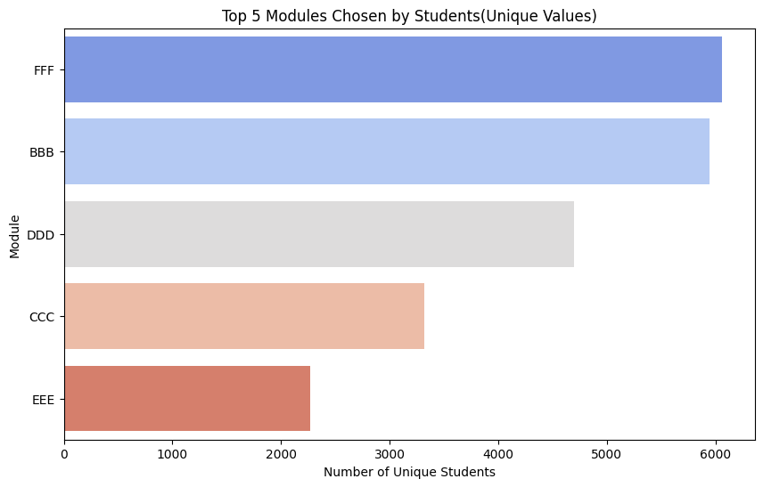
Fig.1

- The top 5 modules with the highest average score
Number of Modules with Highest Average Score (Unique Values):
EEE 81.441304
GGG 79.942976
FFF 78.300051
BBB 76.810892
CCC 74.522153

- Highest Average Score:
Students in general also perform well in Module EEE, because it has the highest average score of all (81.44). Perhaps it is because there is accessible course material, effective assessment strategy, or the students have been engaged.
- Lowest Among Top Modules:
The lowest average score of the top performing modules is CCC (74.52). Though the content or assessments in this module may be a bit more challenging, this module is still very high.

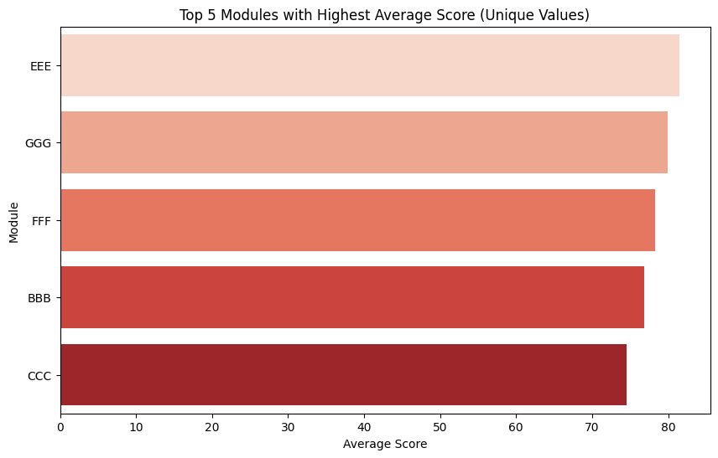

Fig.2
- The top 5 modules with the lowest average score
Number of Modules with Lowest Average Score (Unique Values):
AAA 69.441568
DDD 70.597105
CCC 74.522153
BBB 76.810892
FFF 78.300051
- Lowest Average Score:
The lowest average score is 69.44 and occurs in the Module AAA. This module could be a challenge for students, some of whom may find it difficult content, assessment or engagement wise.
- Challenging Modules:
Likewise, modules DDD (70.60) and CCC (74.52), have relatively low average scores, suggesting areas with potential for a simplified module or support.
- Higher but Still Among the Lowest:
Modules BBB and FFF are again among the lowest scoring modules, although they have better relative performance than others. What this means is that these modules are less of a problem but have potential for improvement.
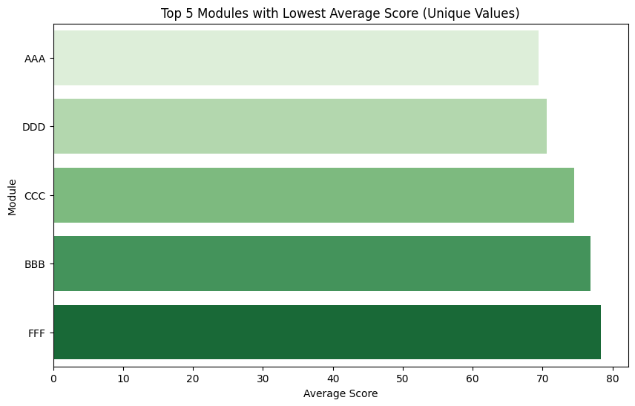
Fig3.

- The top 5 modules with the most number of fails
Number of Modules with Most Number of Fails(Unique):
FFF 1461
BBB 1423
DDD 1173
CCC 670
GGG 485
- Most Number of Fails:
It is Module FFF which has most student failures (1,461). Immediate attention to identify and address factors that lead to these outcomes may be required for this module.
- Significant Challenges in BBB and DDD:
Both modules BBB (1,423) and DDD (1,173) also show high failure rates, suggesting that systemic problems may need both short term and long-term solutions.
- Lower Failure Rates in CCC and GGG:
The modules CCC (670) and GGG (485) have fewer failures than the top three modules, but such anomalies must be investigated.
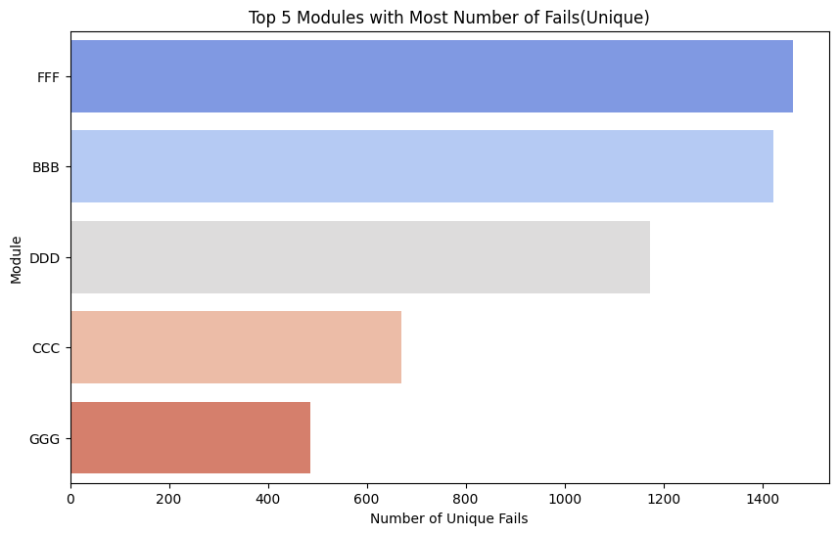
Fig.4
- The age distribution of the students:
Age Band:
0-35 1081730
35+ 498294
- Younger Students (0–35):
An overwhelming majority of student (68.45%) falls in the 0–35 age band, which suggests that there is a substantial segment of the student body which is attending higher education on the transition from traditional university years or in the early stages of its career.

- Older Students (35+):
Overall, approximately 31.55% of students are mature learners aged 35 and above and may be returning to education to enable them to advance their careers, increase their skill base or to enhance their personal development.

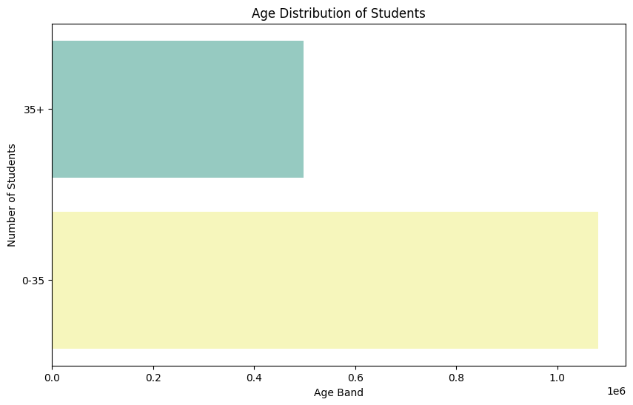
Fig.5

- The weekly activity patterns of the students' interaction with the VLE
- Engagement Peaks and Troughs: Specific weeks with high activity then were seen in the visualization, the most likely being due to key academic dates such as assessment deadlines, announcements or collaborative activities. For some people, breaks may occur in weeks when activity is lower (perhaps due to less course intensity, reduced motivation, etc.)
- Consistent Trends: Student activity at the beginning of the course tends to be high in many modules as students come back to the content in one or more modules and work through the first few tasks. Time to engagement fluctuates mid-course, and has renewed peaks closer to assessments or project submissions.
- Late-Course Trends: It's possible that activity levels drop off at the end of the course because engagement is diminished after assessment periods have come to an end.
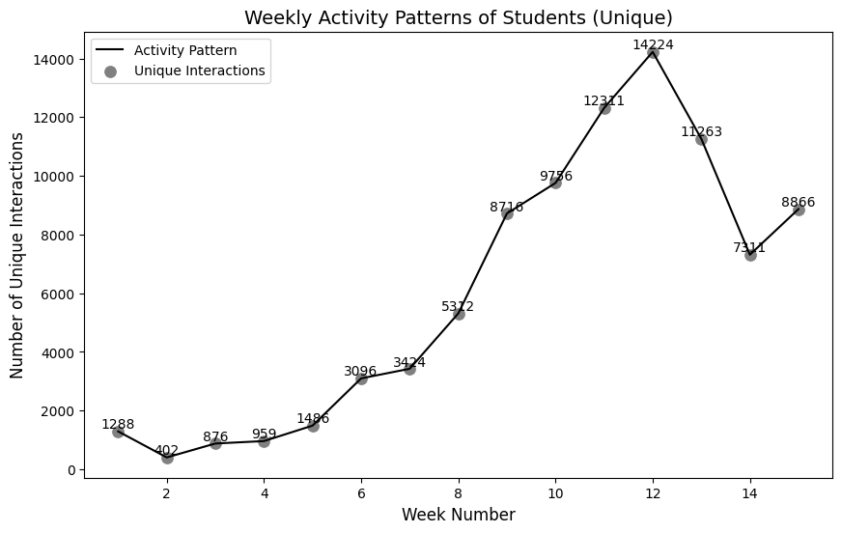

Fig.6

Methods

Hypothesis Test:
Hypothesis tests are conducted to determine if relationships between engagement metrics (e.g., Module Engagement Rate, Activity Diversity, and Assessment Engagement), and student grades are statistically significant. By doing this, it can also help see if the metrics we have as predictors for academic performance on a VLE are reliable.
Hypotheses for Each Metric
Following hypotheses were tested:
- Null Hypothesis :There is no significant relationship between the engagement metric and student grades.
- Alternative Hypothesis :There is a significant relationship between the engagement metric and student grades.
The hypotheses were tested at a 95% confidence level (α=0.05).
T-Test:
For each of the metrics we compare the means of student grades between different levels of engagement (low vs high) using two sample t tests. Engagement metrics were split into two groups by used threshold value (e.g. split at the median).
T-Test Statistic: It measures the size of the difference compared to variation of the sample data. As the t-value gets larger the difference between the groups is greater.
P-Value: The probability of observation of the results if the null hypothesis is the case. A p-value less than. 0.05 indicates rejecting the null hypothesis.
Metric | T-Test Statistic | P-Value | Interpretation

Module Engagement Rate | 12.7121 | 5.0842e-37 | The grades for high and low engagement groups are statistically significant because the p-value is extremely small.

Activity Diversity | 643.7940 | 0.0000e+00 | Based on activity diversity, there is a highly significant difference in grades; the p-value is effectively zero.

Assessment Engagement | 76.3764 | 0.0000e+00 | The significance of the difference of grades on the assessment engagement levels is the same as p-value of zero.

Tabel.1
- Module Engagement Rate: It is defined as a ratio of all module interaction to the maximal recorded interactions.
- Activity Diversity: It measured the number of total unique activities a student worked with in the course.
- Assessment Engagement: Based off the quantity and quality of assessments a student completes.

The following assumptions were considered to ensure the validity of the t-tests:
- Independence of Observations: Every student’s engagement scores and grades are independent from each other.
- Normality: The grades of each group are approximately normally distributed. This was tested using visual methods (histogram, Q-Q plots) and also the statistical tests (Shapiro-wilk test).
- Homogeneity of Variances: Levene’s test was used to check the variance of grades between the two group.

Correlation Analysis Results:
- This certification engagement score (Correlation = 0.0154) :
The coefficient of the Assessment Engagement Score with regards to student grades is 0.0154 which shows a very insignificant positive directionality. This means that the more engagement in assessments, as captured by this score has very near zero correlation with student grades in a linear trend sense.
- Module Engagement Rate (Correlation = 0.0660) :
The correlation between Module Engagement Rate of students and their grades is 0.0660. It means that it has a low positive relationship between them. This, even though slightly higher, indicates a reasonably weak correlation, to put it mildly.
- Activity Diversity (Correlation = 0.5237) :
The relationship between Activity Diversity and student grades is of 0.5237, which means moderate to strong positive correlation. This suggests that in academic terms students with a wider awareness of and engagement in activities within the VLE, outperform those with a narrower focus.

Statistical Model:
Decision Tree Classifier:
The machine learning algorithm we used for classification purposes is called a Decision Tree Classifier. Using this it predicts outcomes by learning decision rules inferred from the data features.
The Decision Tree Classifier takes the dataset and divides it into smaller sets by setting feature thresholds at each node finally, the resulting tree will be in the form of a tree, where each node represents a decision and the leaves mark out the outcome we expect (i.e., pass/fail, high/low grades).
Decision Tree Classifier: Why We Used it.
- Interpretability: Machine learning models such as Decision Trees are highly interpretable as opposed to other models. This makes the decision-making process visually useful in the tree structure, in demonstrating which features are mainly contributing to predicted student outcomes. Especially for educational analysis, one needs to know why predictions are so and not their accuracy, so valuable is this.
- Feature Importance: This Decision Tree Classifier reveals feature importance, by which engagement metrics are the most important predictors of outcomes (Module Engagement Rate, Assessment Engagement, Activity Diversity). It allows you to prioritized some of the more actionable interventions and resource allocation.
- Ease of Use with Mixed Data Types: One of the strongest qualities of Decision Trees, which makes them a natural choice as the classifier in the OULAD, is their ability to work with both categorical (e.g., student demographic data) and numerical data (e.g., cumulative scores, engagement rates).
The Decision Tree Classifier Helps, in How…
- Predicting Student Outcomes: The Decision Tree Classifier uses a student's engagement metrics and their cumulative scores to predict whether the student will perform well, fail, or need intervention. With this predictive ability, we can identify at risk students early.
- Driving Targeted Interventions: Once the key factors impacting success or failure have identified, institutions can design relevant interventions. For example: Low activity diversity students may need guidance on utilizing a wide variety of resources. Therefore, in that way they could be encouraged to complete assignments with better preparation, if their Assessment Engagement Scores are low.
- Enhancing VLE Design: Examining the decision paths will allow us to see how students interact with a Virtual Learning Environment (VLE) and change it to encourage behaviors that lead towards success. For example, what features high performing students use heavily can be betted or gamified.

Results:

Interpreting the results.
1.Student Grades and VLE Engagement
Hypothesis: The student grades are better with increased engagement with VLE.
Findings:
The data suggests the more that students were engaged in the VLE, whether it be through regular interaction with the materials in the VLE, participation in online discussion forums or completion of VLE related activities, the better the grades students attained. It means that those students who actively use the VLE are, in fact, performing better in academics.
Implications:
The VLE can be used in a way that promotes regular engagement which will help students stay on track with course content and assignments.

2. Activity Diversity and Student Grades.
Hypothesis: Improved academic performance is associated with more diverse student activities.
Findings:
Analysis unearthed that activity diversity, i.e., the range of activities a student takes part in different activity has a major effect on the grades obtained by the student. Students that participate in many different activities are more academically successful.
Implications:
If students engage in different kinds of activities, they are more likely to grasp material in the course more adequately.
Several different ways (e.g. lectures, readings, collaborative tasks) to learn on offer means students have more chances of being successful.

3. Assessments, Engagement and Student Grades
Hypothesis: Involving students in the assessment increases student grades, though it increases the effort for teachers.
Findings:
It largely support that assessment engagement does indeed have a huge influence on the student grade: completing assignments, watching quizzes, etc. A positive correlation exists between engagement with assessments and academic performance—it seems to be the case that students who engage more deeply with assessments do better in their studies.
Implications:
By encouraging students to continue to work with assessment all semester, it not only allows opportunities for learning but it also keeps it in the forefront of their minds.
Further optimizing student performance can be done through timely feedback on assessments and through creating opportunities for reflection.

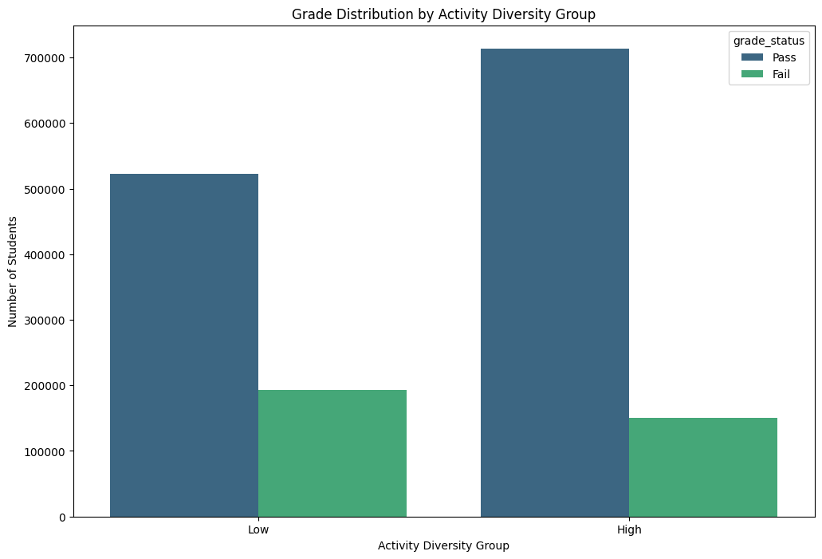
Fig7
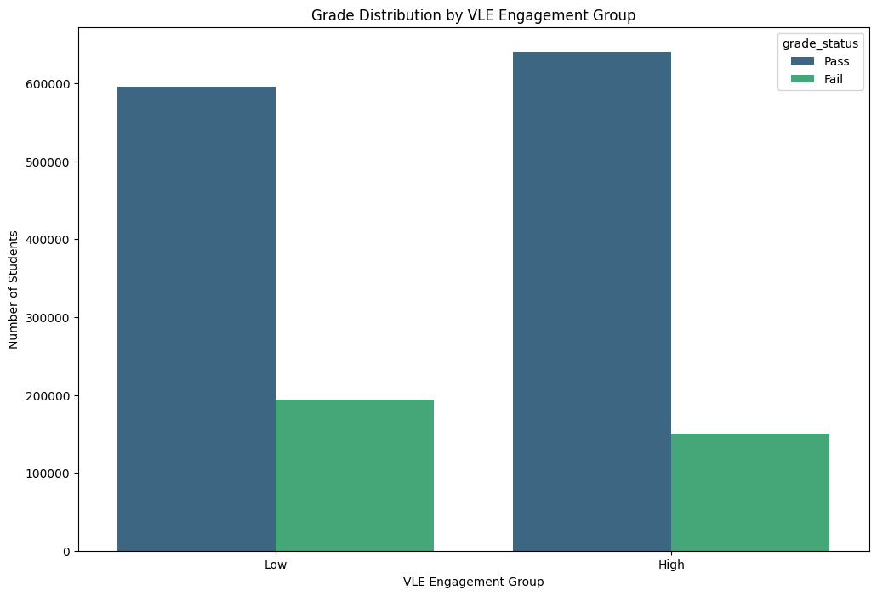
Fig.8
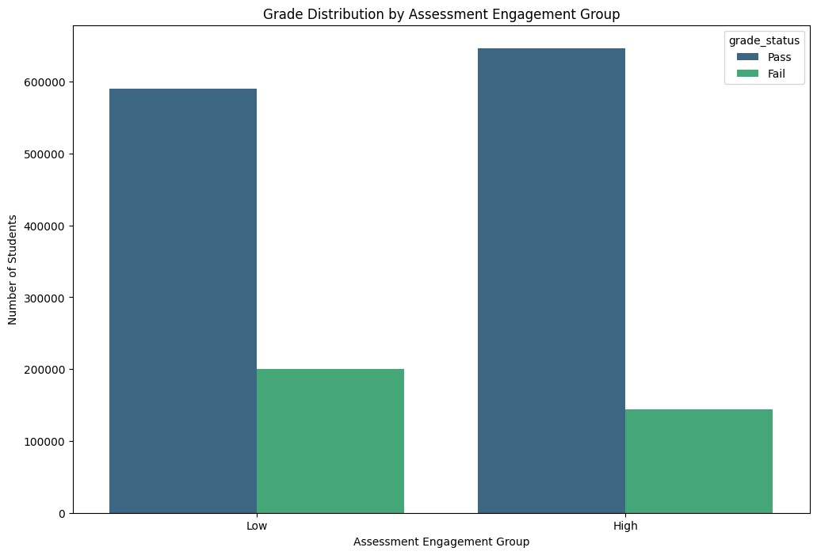
Fig.9
Using Decision Tree Classification :
Key Metrics Explanation:
Precision:
Precision is the percentage of correct positives in all the predicted positives as true positives (true positives + false positives). When the high precision value is taken, it shows that the model predicts out false positives, but not credit.
Recall:
A recall is a measure of what percentage of actual positives (true positives + false negatives) were correctly predicted. Recall means the model does well in finding positive cases, albeit at a price of some false positives.
F1-Score:
Harmonic mean i.e. F1 score combines the precision and recall in an average that gives balance between the two. This is particularly useful when working with imbalanced classes, as it reduces to both precision and recall, into a single metric.
Support:
This metric supports each class with the number of occurrences in the dataset, to put the other metrics into perspective. Thereby it gives some idea of how the model performs on different class distributions.

Class | Precision | Recall | F1-Score | Support

-1 | 0.85 | 0.50 | 0.63 | 32,491

0 | 0.81 | 0.61 | 0.69 | 70,698

1 | 0.82 | 0.95 | 0.88 | 295,830

2 | 0.86 | 0.67 | 0.76 | 74,989
Tabel .2

Discussion
Results, Limitations and Actionable Advice Substantiation:
The analysis highlights the key factors impacting student grades: Activity diversity, assessment engagement and VLE engagement. Evidence suggests that higher student grades are associated with higher engagement with the Virtual Learning Environment (VLE), confirming that continuous engagement with course content and conduct of activities increases in reaching better grades. Similarly, students who do a great number of activities like discussions, quizzes and assignments, score better academically. So, this means that learning opportunities from diverse perspectives improves understanding and retention. Finally, having the students actively participate in the assessments also raises their grades significantly, demonstrating that the assessments are not only for use as grading, but also for providing reinforcement for learning.

But several limitations still exist on this topic. In the given classification model, there is class imbalance, especially in Class -1 which suffers from low recall and hampering in detecting low performing students. Furthermore, motivation or existing prior knowledge are not considered in the analysis of academic outcomes. Such dataset might also have some missing or incomplete data that might yield biased predictions of the model.

However, the results can give educators actionable advice. The inclusion of interactive elements, such as quizzes, forums, increase regular VLE engagement and helps boost student performance. It is through offering a variety of activities to appeal to different learning styles, that helps promote deeper engagement. In addition, students will continue to focus on assessments that are also accompanied by feedback at regular intervals. In addition to monitoring engagement trends, the opportunity is given to support during periods of low activity so that no student is left behind.

These recommendations are data grounded, with clear actions that can improve student engagement and academic performance in coming courses. If institutions start to focus on these areas, reaching these goals will become possible and will result in a more supportive and effective learning environment that will overall improve student outcomes.

Conclusion:
The focus of this report was on the factors impacting student grades using VLE engagement, activity diversity, and assessment engagement. Data exploration and statistical analysis were done to identify the indicators of high academic performance and these findings showed a positive relationship between the high academic performance and the level of engagement with VLE, level of activity diversity and participation in assessments. These results support the hypothesis that improved results follow active and varied student engagement.

Nevertheless, they noted limitations including class imbalance in predicted, possible missing data and lack external factors (i.e., motivation and previous experiences). For larger classes (e.g., Class 1), the classification model did well but underrepresented classes need attention in subsequent analysis.

Actionable Recommendations
Based on the findings, the following recommendations are made to enhance student outcomes:

Encourage Consistent VLE Engagement: There is an interaction with the VLE on an ongoing basis and the effect this has on performance is positive. To make sure students stay interested across a course, we need institutions to consider adding interactive features like quizzes, forums, and multimedia content.

Increase Activity Diversity: It provides a balance of the activity types (e.g. discussions, assignments and quizzes) to accommodate each one’s learning style and to make them feel more engaged in a deeper way. This variety is an essential for helping students to learn better and attain better grades.

Promote Frequent Assessments: By continuous assessment and timely feedback, students are able to keep track of progress and close in on learning gaps as they develop. Forms of formative assessments, like quizzes and peer reviews will lead students to get engaged in learning and make them work better.

Access to the data underlies these recommendations and routes to them stem from the analysis. However, by investing in these strategies, institutions can create an environment that sustains better academic performance, better student engagement, and more success down the road in courses.

